

|  |  |  |
| --- | --- | --- |
|  | **Model Development Phase Template** | |
|  |  |  |
| Date |  | 10th July 2024 |
| Team ID |  | 739958 |
|  |  |  |
| Project Title |  | Food Demand Forecasting for Food Delivery |
|  |  | Company |
|  |  |  |
| Maximum Marks |  | 5 Marks |
|  |  |  |

**Feature Selection Report Template**

This report presents the results of feature selection analysis conducted for food demand forecasting in the context of a food delivery company. The goal was to identify the most influential features that contribute to accurate demand predictions, ultimately optimizing resource allocation and operational efficiency.

|  |  |  |  |  |
| --- | --- | --- | --- | --- |
| **Feature** | **Description** | **Selected (Yes/No)** | **Reasoning** |  |
| Time-related | Hour of day, | Yes | Time-related features capture daily, weekly, |  |
| Features |  | and seasonal demand patterns, influencing |  |
| Day of week, |  |  |
|  |  | ordering behaviour. |  |
|  | Month, |  |  |
|  |  |  |  |
|  | Seasonality |  |  |  |
|  | indicators |  |  |  |
|  |  |  |  |  |
| Customer | Age, Gender, | Yes | Customer demographics provide insights |  |
| Demographics |  |  |
| Location |  | into preferences and ordering habits based on |  |
|  |  |  |
|  |  |  | location and demographic factors. |  |
|  |  |  |  |  |
| Customer | Membership | Yes | Loyalty status influences frequency of orders |  |
| Loyalty | status, Loyalty |  | and customer retention, impacting long-term |  |
| Status |  |  |
| points |  | demand trends |  |
|  |  |  |
|  |  |  |  |  |
| Order-related | Number of items, | Yes | Order-related features directly correlate with |  |
| Features | Total order value, |  | transaction size and promotional |  |
|  |  |  |
|  | Special |  | effectiveness. |  |
|  | promotions |  |  |  |
|  |  |  |  |  |
| Weather | Temperature, | No | Weather impacts consumer behavior, |  |
|  |  |
| Conditions | Precipitation, |  | affecting demand for certain types of food |  |
|  | Weather type |  | during different weather conditions. |  |
|  | (e.g., sunny, |  |  |  |
|  |  |  |  |  |

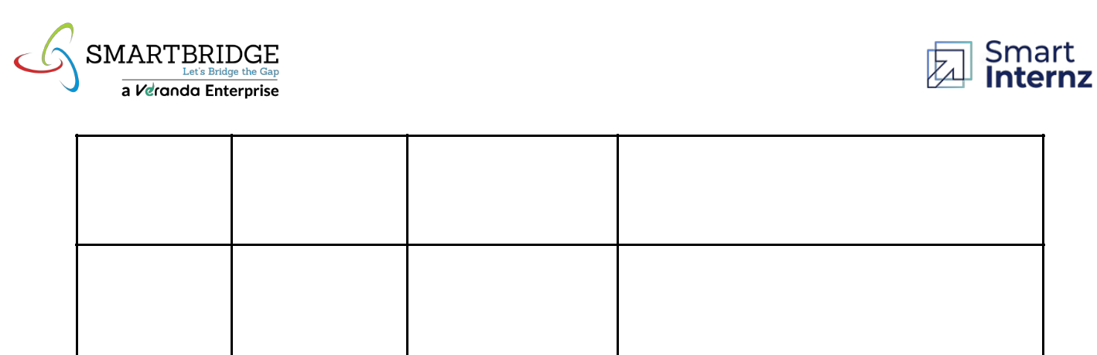

rainy)

|  |  |  |  |  |
| --- | --- | --- | --- | --- |
| Holiday | Public holidays, | Yes | Holidays and festive periods drive unique |  |
|  |  |
| Indicators | Festive seasons |  | demand patterns, requiring special |  |
|  |  |  | forecasting considerations. |  |